#LESSON PLAN
The lesson will begin with a discussion on how computers represent all types of data using binary numbers. Students will learn how numbers are converted between binary and decimal to understand how data is processed internally by computers. The lesson will conclude with step-by-step practice of binary data conversion to build accuracy and confidence..
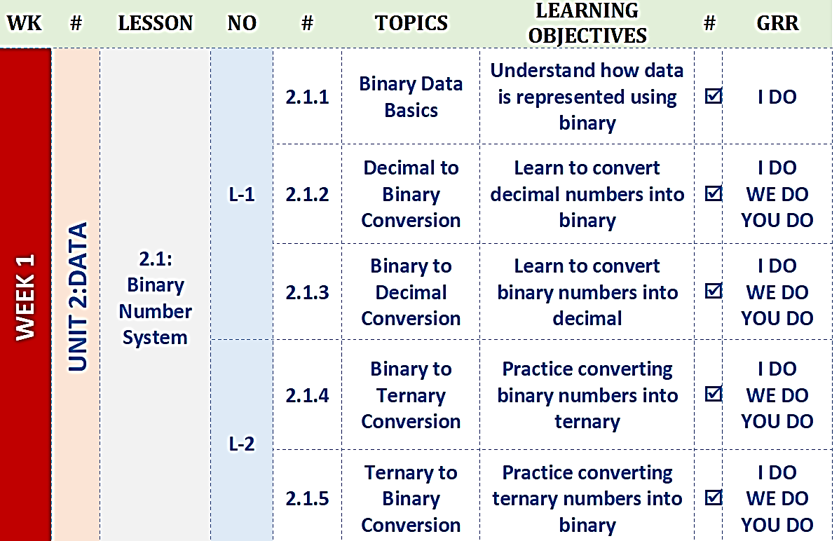

#STARTER
How do computers understand numbers when they can only use 0s and 1s, and why is the binary number system more suitable for computers than the decimal system we use in daily life? Where do we encounter binary data in everyday digital devices such as computers, mobile phones, and the internet, even if we do not see it directly? How does converting data between binary and decimal help computers store, process, and transmit information efficiently?


# LESSON OBJECTIVES
The lesson objectives focus on helping students understand how data is represented and processed using the binary number system. Through this lesson, students will learn the purpose of binary data conversion, how to convert numbers between binary and decimal forms, and why these conversions are essential for accurate data storage and communication in computer systems.
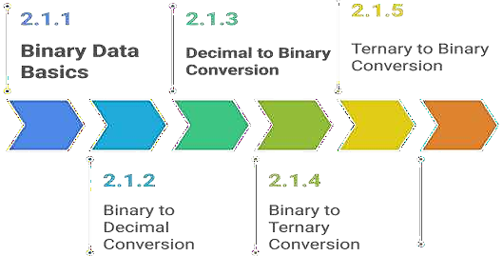
#2.1: Number Systems
Number systems are ways to represent and express numbers using different bases. They are essential in computing for storing, processing, and communicating data.
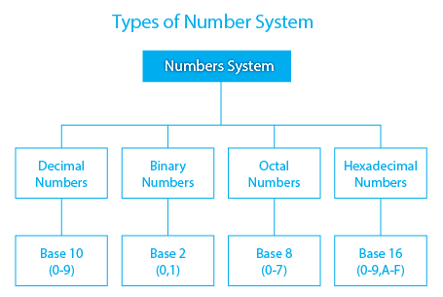

#2.1.1 Binary Data Basics
The Binary Number System is a base-2 number system that uses only the digits 0 and 1. It is the fundamental language of computers, as all data and instructions are represented in binary form. Each binary digit (bit) represents an on or off state in electronic circuits.
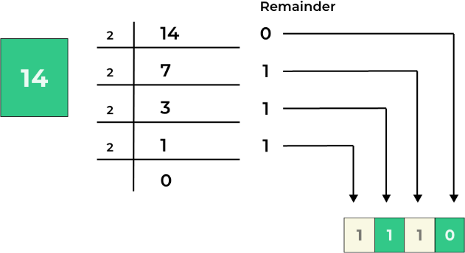

#2.1.2 Decimal to Binary Conversion
Binary data stores information using just two values: 0 and 1. These values are called bits, which form the basic building blocks of digital data. Computers use combinations of bits to represent numbers, text, images, and other information. Gaining knowledge of binary data helps learners understand the internal working of computer systems. Every digital device, such as smartphones, tablets, and laptops, depends on binary data to function.
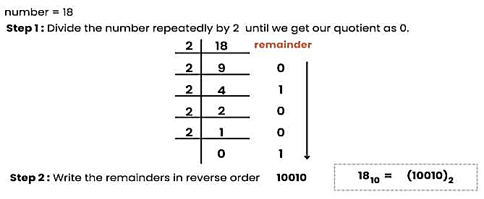
# Represent the number 13 in binary:
The number 13 can be represented in binary by expressing it as a sum of powers of 2. In the binary system, each digit (bit) represents a power of 2, starting from 202^020 on the right. By identifying which powers of 2 add up to 13, we can determine its binary equivalent.
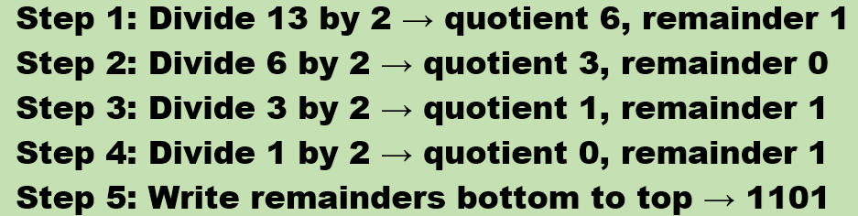
#Lab-WK-1-L1 Practice Examples
- Convert the decimal number 45 into binary using the standard decimal-to-binary conversion process and show the final binary result.
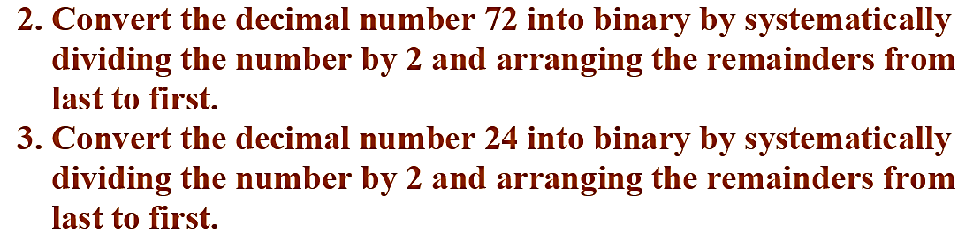

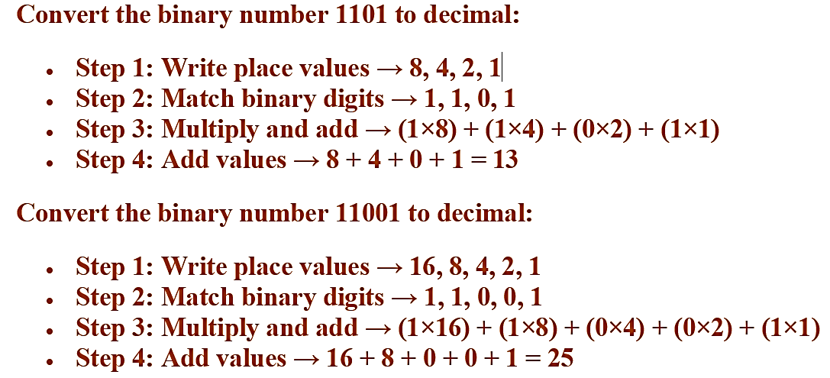
#2.1.3 Binary to Decimal Conversion
Examples:
Convert the given binary numbers to decimal number

#Lab-WK-1-L1 Practice Examples
Complete the given Lab Exercises.
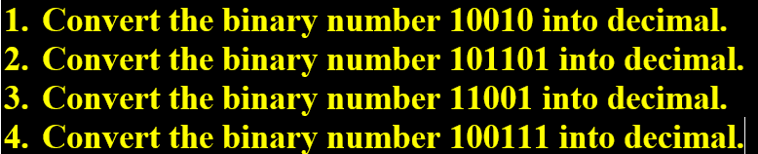
#2.1.4 Binary to Ternary Conversion
Binary to ternary conversion involves transforming a number from base-2 into base-3 form. The binary system works with only 0 and 1, whereas the ternary system uses 0, 1, and 2 as its digits. In this method, the binary value is first changed into a decimal number, which is then converted into ternary form.
This conversion process helps students understand how different number systems are connected and applied in computing concepts.
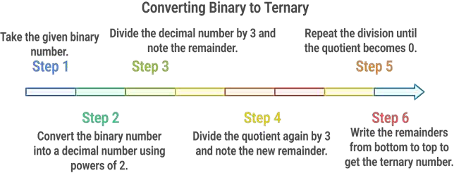

#2.1.5 Ternary to Binary Conversion
Ternary to binary conversion refers to changing a number from base-3 into base-2 form. The ternary system uses the digits 0, 1, and 2, whereas the binary system works with only 0 and 1. In this approach, the ternary value is first changed into a decimal number, which is then converted into binary format.
This process helps students develop confidence in working with multiple number systems.
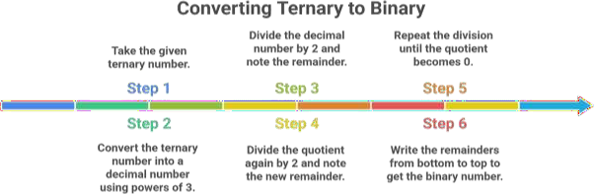

#SUMMARY
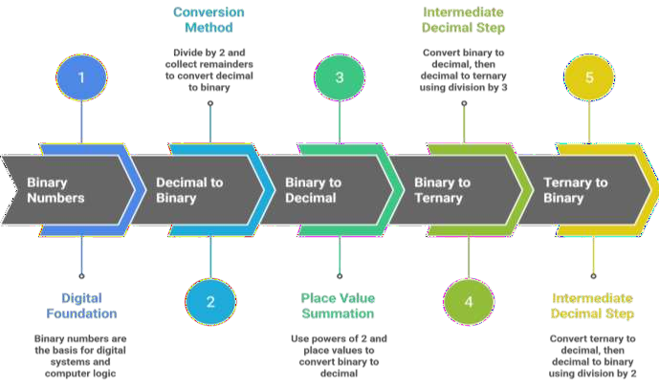
What we learnt

